I hereby give JTJ Youth Transportation permission to use a booster seat for the transportation of my child. I confirm that my child meets the State of Georgia requirements for booster seat use, including the appropriate age, weight, and height guidelines.

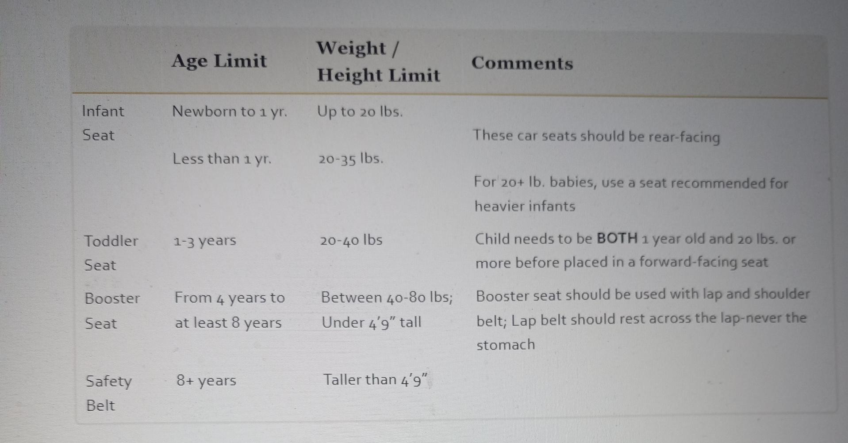

Parent/Guardian Signature: ___________________________________
Date: ___________________

